Congratulations!
Congratulations on the expected birth of your newest family member! Your decision to deliver your baby at Saint Clare's Denville Hospital is a good one. All of us here will do whatever is necessary to make your stay as pleasant and memorable as possible.
To assist in a smooth and speedy admission when you arrive to have your baby, we ask that you fill in the enclosed form and bring it with you when you come to: Labor and Delivery, Saint Clare's Denville Hospital, 25 Pocono Road, Denville, NJ 07834. When you come to deliver, please go directly to the 3rd floor, Katena Center, Denville.
You must register at Outpatient Registration if you come to Saint Clare’s for prenatal tests, lab tests or any other procedure regarding your pregnancy.
If you have any questions or concerns, or would like a tour, feel free to call 973-625-6387.
Please read the instructions below before you fill out the enclosed form. This form must be printed in ink, signed and completed. If this form is incomplete, it will be returned to you. Please include one copy of both sides of your health insurance cards, and a copy of your driver’s license or other photo identification.
Again, congratulations. We wish you and your family much joy in the months and years ahead.

PREADMISSION FORM
- Personal Information: Information about you: home address, expected due date, religion, doctor and whether you have an Advance Directive. If you have an Advance Directive please send a copy. If you would like information, please check where indicated.
- Employer Information: This section requests information about your employer. If you are not employed, check the appropriate box.
- Next of Kin: Who would we contact in an emergency? That information goes into this section.
- Primary Insurance: Who is responsible for paying all hospital bills associated with your pregnancy, delivery and recovery? The Responsible Party is the person who carries the primary insurance and should sign as guarantor of account. This person is the subscriber.
- Secondary Insurance: Please complete as applicable.
Remember to sign, date and include a copy of both sides of your insurance card(s). If your insurance changes prior to delivery, please make sure to provide the Hospital with the new information.
If you have any questions about this form or the process, please call 973-625-6524.
Pocono Road
25
Denville, New Jersey 07834
saintclares.com
6061-109(5/17)
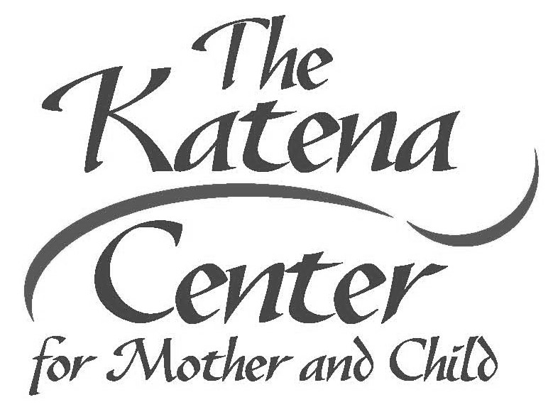
SAINT CLARE’S HOSPITAL
PREADMISSION FORM PATIENT LABEL

Please read the instructions contained in the cover letter before you complete the form. Print in ink and return as soon as possible prior to your delivery date.

PERSONAL INFORMATION
Name: Last First
❑ Married  Single Date of Birth:
Social Security Number:
Doctor’s Name:

Due Date:
Email: Smoker:  Yes  No
Street Address:
Town: State: Zip: Phone: Church/Parish:
Religion:

Race / Ethnicity:  Black  White  Asian/Pacific Islander  Hispanic  Other
EMPLOYER INFORMATION
Employer Name:
Street Address:
Town: | State: | Zip:
Phone:  Employment Status:  Full Time  Part Time  Not Employed  NEXT OF KIN INFORMATION | Occupation:
Name: Last | First
Relationship:
Street Address:
Town: | State: | Zip:
Phone: Work Phone:
PRIMARY INSURANCE INFORMATION
Subscriber’s Name if different from patient: Date of Birth:

Social Security Number:
Employer:

Relationship to Patient:

Insurance Company Name:

Policy Number:

Insurance Company Address:

Group Number:

Insurance Company Phone Number (on insurance card):
SECONDARY INSURANCE INFORMATION
Subscriber’s Name: Date of Birth:
Relationship to Patient:

Employer:

Social Security Number:

Insurance Company Name:

Policy Number:

Insurance Company Address:

Group Number:

Insurance Company Phone Number (on insurance card):
I hereby certify that the above statements are correct.

Signature:

Date:
6061-110(3/15)

*1005*

